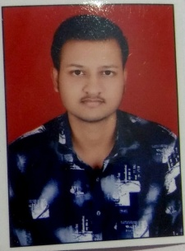**RESUME**

**KSHIRSAGAR NILESH SITARAM**

+91 9356879424

Email Id : nkshirsagar088@gmail.com

**OBJECTIVE**

Looking to establish a career in the field of IT,I wish to work in a growth-oriented company and contribute to the development of the organization while upgrading my skill set and knowledge.

**EDUCATIONAL QUALIFICATION**

* Pursuing B.SC(CS) 3rd year from SRTM University.
* Passed out 12th from Maharashtra State Board in 2020

Marks : 52.77%

* Passed out 10th from Maharashtra State Board in 2018

Marks : 77.60%

**OTHER ACADEMIC DETAILS**

**Mini Project:**

* I made a calculator using html, CSS , JavaScript which performs calculations like arithmetic operation
* I made a voice-based assistant using python

They allow a search to be carried out using a voice command entered by user as well as information retrieval by voice synthesis.

**TECHNICAL SKILLS**

* Programming Languages : JavaScript , Python , MYSQL ,CSS, HTML,BOOTSTRAP
* IDE : Visual Studio Code, Notepad

**STRENGTH & HOBBIES**

* Positive Attitude
* Team Work Skill
* Effective Time Management
* Travelling and Listening Music

**PERSONAL DETAILS**

Gender : MALE

Address **:** VIJAYGAD COLONY,YAKATPUR ROAD,AUSA-413520

Marital Status : SINGLE

DATE: 15-09-2022 (KSHIRSAGAR NILESH)